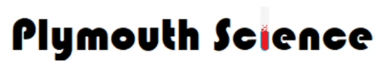
Year 5
Forces
Knowledge Organiser

r
An English mathematician, physicist, astronomer and author who is famous for his laws of motion, theory of colour and the discovery of gravity. Gravity is measured in Newtons (N)
Sir Isaac Newton
1643-1727
VOCABULARY
Forces- changes the motion of an object. Pushes and pulls in a particular direction.
Gravity- a force which pulls things towards the centre of the Earth. Discovered by Sir Isaac Newton.
Earth’s gravitational pull- pull that Earth exerts on an object pulling it towards the Earth’s centre.
Weight- The measure of the force of gravity on an object.
Mass- a measure of how much matter (stuff) is inside an object.
Air resistance- resistance or drag, acts against gravity on falling objects.
Water resistance- type of force that uses friction to slow things down that are moving through water.
Resistance- a force between surfaces that are touching.

nnh

Types of forces.
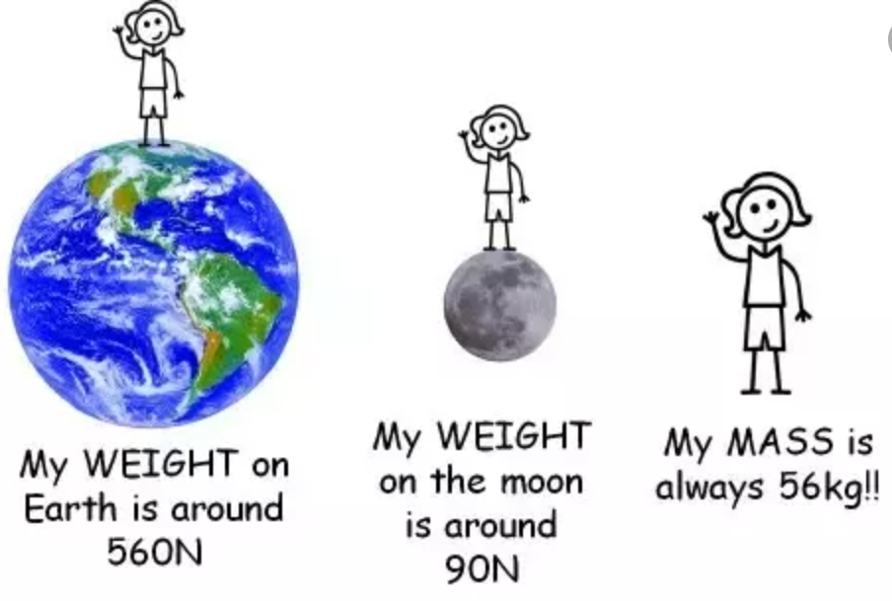

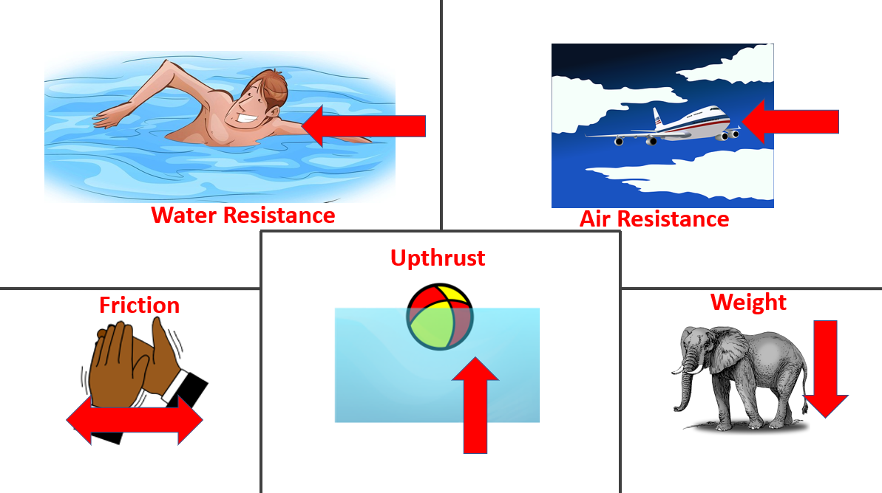

The weight of an object is caused by gravity pulling down on it. Objects with more mass have a greater weight, as the force of gravity pulls them down more strongly.


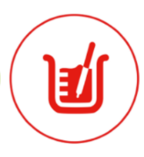






Year 5
Forces
Measuring Time
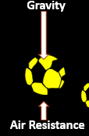
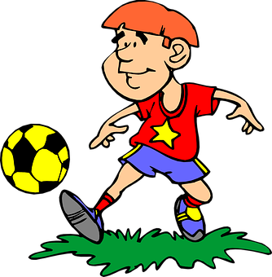
Galileo Galilei
1564-1642
Studied speed and velocity, gravity and free fall. He invented thermoscope and military compasses. He measured time using pendulums.

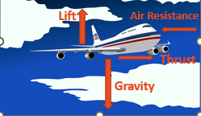
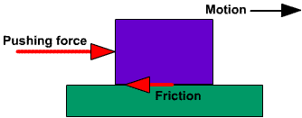
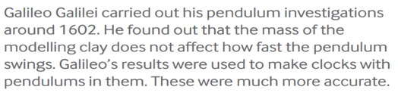

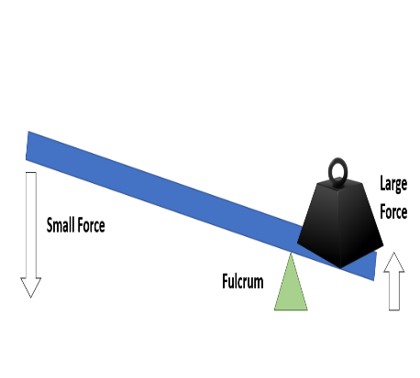
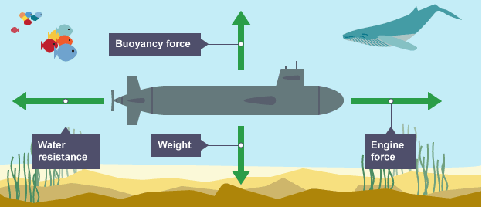
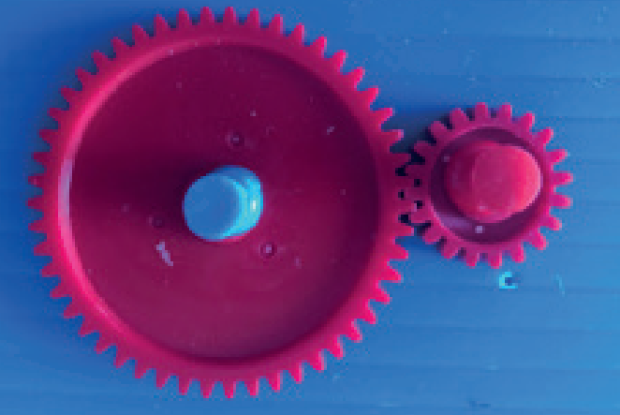
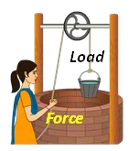



Water resistance.
This submarine is streamlined, it has a pointed front to cut through the water and a smooth body to allow the water to flow over it.

Gears or cogs can be used to change the speed, force or direction of a motion. They turn in opposite directions when connected.
Gears and Cogs
Can be used to make a small force lift a heavier load. A lever always rests on a pivot.
Can be used to make a small force lift a heavier load. The more wheels in a pulley, the less force is needed to lift a weight.
Pulley
Levers, pulleys, gears and cogs.

