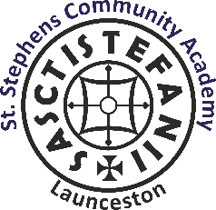
ST STEPHENS COMMUNITY ACADEMY
Roydon Road, Launceston, Cornwall PL15 8HL
Tel: 01566 772170
E-mail: ststephens@andaras.org
www.ststephenscornwall.co.uk
‘Embracing Learning. Inspiring Ambition. Celebrating Individuality’
Head Teacher: Maura Furber

Year 6 Bikeability: Autumn Term 2021
13.7.21
Dear Parent/Carer,

We will be offering 2 Bikeability courses, (Learn 2 Bike and Bikeability Level 2), run by Arena, in the Autumn Term. We have attached the details of the course which your child has expressed an interest in joining. The details of the equipment required to participate are also included. If you would like your child to participate in the Bikeability course, please complete the Parental consent form and return to school by Friday 10th September. Once we have confirmed numbers, your child will be allocated a group and dates when they will complete the course. For the Bike 2 Learn, this will be on Wednesday 29th September. The Level 2 course will either be on Thursday 30th September or Wednesday 6th or Thursday 7th October : you will receive notification of this.

Please note that copies of the forms can also be found on the school website: Class 5 -Transition Tab

Kind Regards
Ms Neale ( Year 6 Teacher/Assistant Head of School)

